

Republic of the Philippines
Department of Education
National Capital Region
DIVISION OF CITY SCHOOLS
Quezon City, Metro Manila

SECOND PERIODICAL TEST
(First Semester Achievement Test)
MATHEMATICS II - SY 2012-2013

DIRECTIONS: Choose the letter corresponding to the correct answer.

1. What is the simplest form of the expression 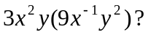
A. 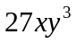 B. 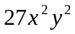 C. 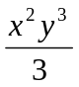 D. 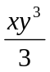
2. Which of the following is a rational expression ?
A. 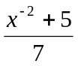 B. 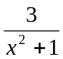 C. 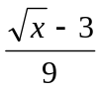 D. 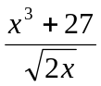
3. If Ronie can finish a job in 9 days, what part of the job is done by Ronie in 1 day?
A. 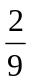 B. C. D. 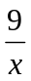
4. Which is the simplest form of 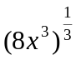 ?
A. 2 B.2x C.2x³ D. 8x
5. In the expression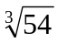, which is the index?
A. B. 2 C. 3 D. 54
6. What is the simplest form of the radical expression 3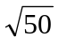?
A. 1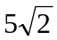 B. 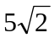 C. 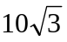 D. 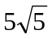

7. Given the radical expression in #5, what does 54 stand for?
A. index B. radicand C. exponent D. coefficient

8. The GCF of 6a³b⁴ and 9a²b⁴ is.
A.3a²b⁴ B.3a³b⁴ C. 18a²b⁴ D. 18a³b⁴

9. Which one is the simplified form of the expression 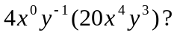
A. 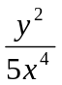 B. 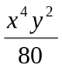 C. 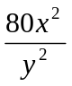 D. 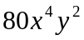
10. Evaluate: ( 20 + 1 )( 20 – 1 )
A. 200 B. 299 C. 399 D. 401

11. Which of the following polynomial is a binomial?
A. 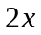 B. 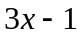 C. 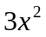 D. 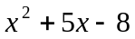

12. Find the sum: 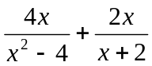. A. 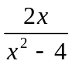 B. 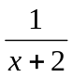 C.  D. 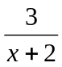

13. Which of the following is the area of a square in sq. dm, if the perimeter is (4x + 12) dm?
A. 4x² − 6x + 24 B. 4x² + 6x + 24 C. x² − 6x + 9 D. x² + 6x + 9

14. If the domain is the set 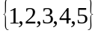, what is the solution set of 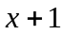 > 3 ?
A. 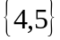 B. 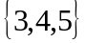 C. 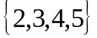 D.

15. Which of the following is the factored form of 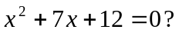
A. (x+2)(x+6) = 0 C. (x + 4)(x + 3) = 0
B. (x-2)(x-6) = 0 D. (x+1)(x+12) = 0

16. When factored, what is the solution set of the quadratic equation 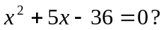
A. {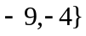 B. {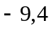} C. {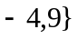 D. {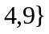
17. Which of the following is the value of y in 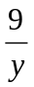 = 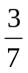?
A. 11 B. 9 C. 15 D. 21
18. Solve the quadratic equation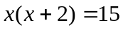.
A. x = 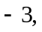 x = 5 C. 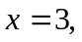 x = 5
B. x = 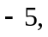 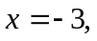 D. 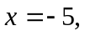
19. What value/s of x will make 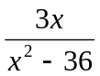 meaningless?
A. 6 and 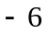 B. 6 and 36 C. -6 and 36 D. -36 and -6

20. What is the product of the roots of 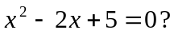
A. −5 B. – 2 C. 2 D. 5

21. Find the quotient: 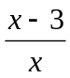 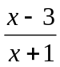. A.  B. 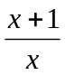 C. 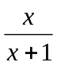 D. 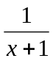
22. What is 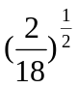?
A.3 B. C. D. 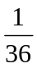
23. Which of the following quadratic equations having 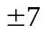 as its roots?
A. x² + 49 B. x² + 14 C. x² - 14 D. x² − 49
24. Express 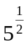 in radical form.
A. 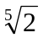 B. 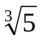 C.  D. 

25. What is 10⁷ divided by 1 million?
A. 0.1 B. 1 C. 10 D. 100

26. Find two consecutive positive odd numbers whose product is 63?
A. 7 and − 9 B. − 9 and − 7 C. 21 and 3 D. 7 and 9

27. Find the roots of the quadratic equation 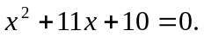
A. { 1, −10} B. { − 10, −1 } C. { −2 , 5 } D. { −2, −5 }

28. Find two real numbers whose sum is 12 and whose product is a maximum.
A. 6 and 6 B. 5 and 7 C.4 and 8 D. 3 and 9

29. What is the simplest form of the radical expression 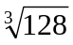 ?
A. 6 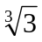 B. 3 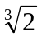 C. 4 D. 6

30. Which of the following is the simplified form of 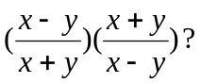
A. 1 B. 2 C. 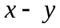 D. 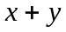
31. Find the simplified form of 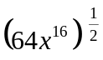.
A. 64x ¹⁶ B.8x⁸ C.64x² D. 8x⁴

32. The length of a rectangular lot is 2 meters more than its width. If the area of the lot is 35 sq. m,
what is the equation representing its area?
A. 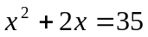 C. 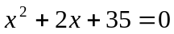
B. 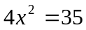 D. 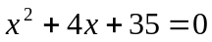

33. What is the width in meters of the lot described in number 32?
A. 2 B. 5 C. 7 D. 12
34. How long in meters is the lot in number 33?
A. 2 B. 5 C. 7 D. 12
35. The time t, in seconds that takes a body to fall a distance of d meters from rest is given by the equation
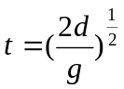, where g is the acceleration due to gravity in m/s². Find t when d = 45m and g = 10m/s².
A. 3 sec B. 4 sec C. 5 sec D. 6 sec

36. One pipe can fill a tank in 12 minutes. Another pipe can fill it in only 8 minutes. How long would it take both pipes to fill the tank?
A. 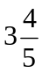 min B. 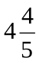 min C. 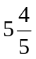 min D. 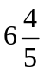 min
37. If the roots of a quadratic equation are 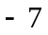 and 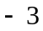, what is its defining equation in factored form?
A. ( x + 7)(x – 3 ) = 0 C. ( x - 7)(x - 3) = 0
B. ( x – 7 )(x + 3 ) = 0 D. (x + 7 )( x + 3 ) = 0

38. A 250 ml solution is 30% salt. How much water should be added to make the solution 12% salt?
A. 250 ml B. 275 ml C. 300 ml D. 375 ml

39. If n is a positive number, which of the following rational algebraic expressions must be less than 1?
A. 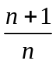 B. 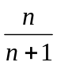 C. 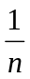 D. 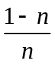
40. What number should be added to the numerator and denominator of to get a fraction that is equivalent to ? A. 5 B. 6 C. 7 D. 8
41. Which of the following is the value of x in 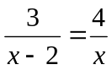?
A. 5 B. 6 C. 7 D. 8

42. If 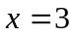 and , what is the value of the expression 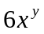?
A. 0 B. 1 C. 2 D. 6

43. What is the LCM of 6a³b⁴ and 9a²b⁴?
A.3a²b⁴ B.3a³b⁴ C. 18a²b⁴ D. 18a³b⁴

44. The ratio of an angle to its complement is 2:3. What is the measure of the angle in degrees?
A. 36 B. 40 C. 48 D. 54

45. What is the measure of the complement of the angle in problem # 44?
A. 36 B. 40 C. 48 D. 54
46. Which of the following is the product of 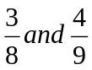?
A. B.  C. D. 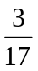
47. If a + b = 22, b + c = 25, and a = 5, what is c?
A. 8 B. 10 C. 12 D. 14
48. The sum of two positive numbers is equal to the sum of its reciprocals. What is the product of these two positive numbers? A. B.  C. 1 D. 2
49. The simplified form of 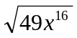 is
A. 49x⁸ B. 49x⁴ C. 7x¹⁴ D. 7x⁸
50. If an orange costs 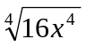pesos, how much will half a dozen costs?
A. P12x B. P24x C. P12x⁴ D. P24x⁴

− GOOD LUCK −

/tvillaluna

